## GUI

### Home Page

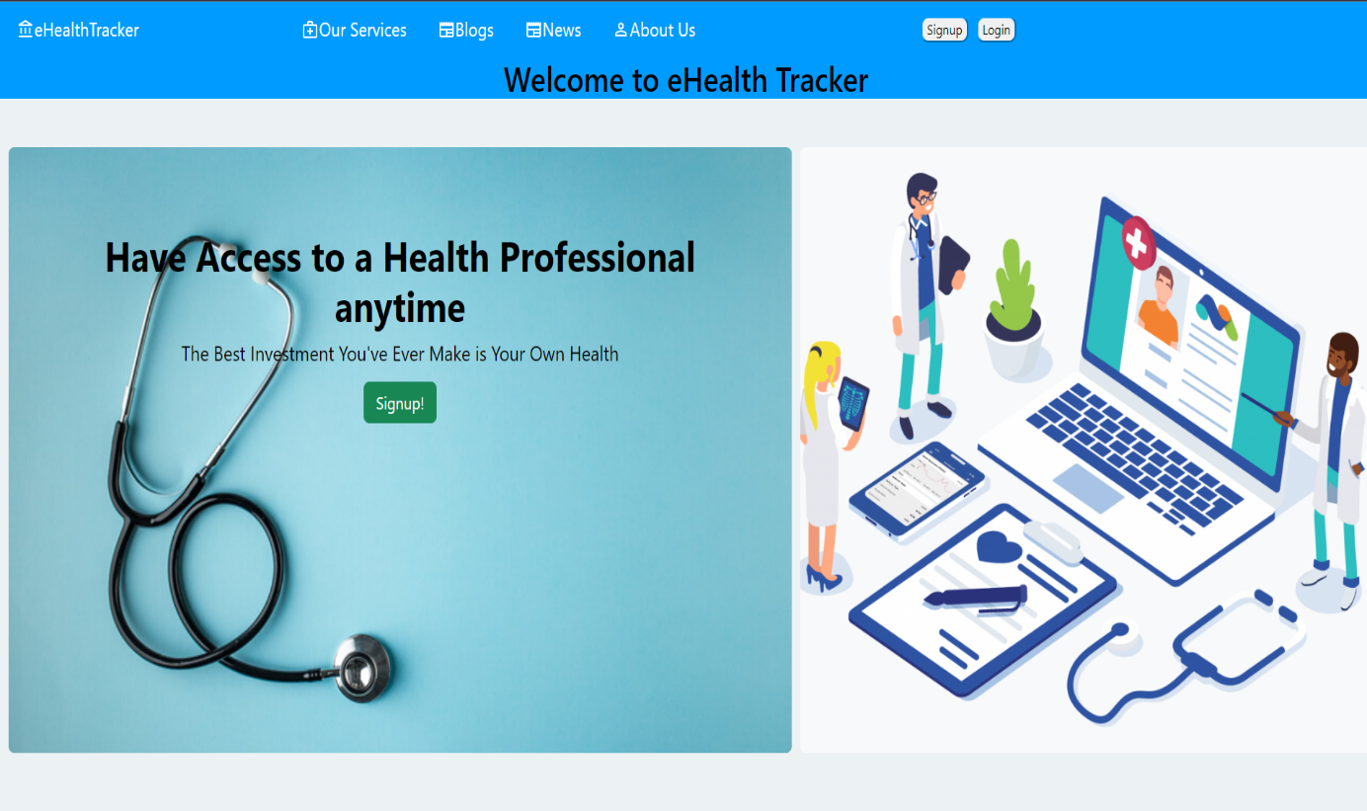

Figure 1.4: Home Page

*It is the homepage of our website.*

### Sign Up

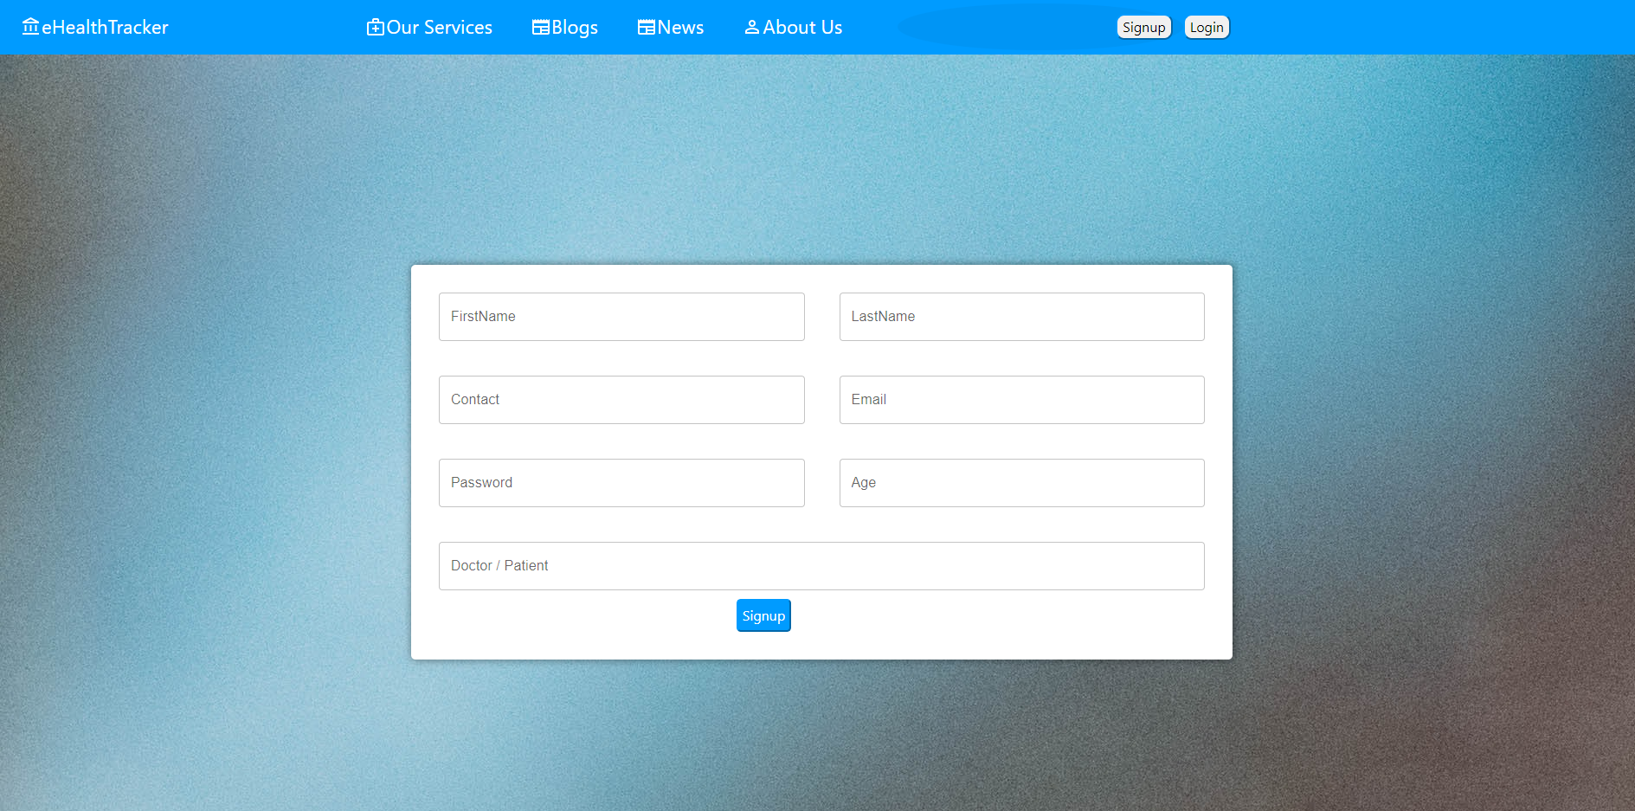

Figure 1.5: Sign up

*Sign up page of our website.*

### Login

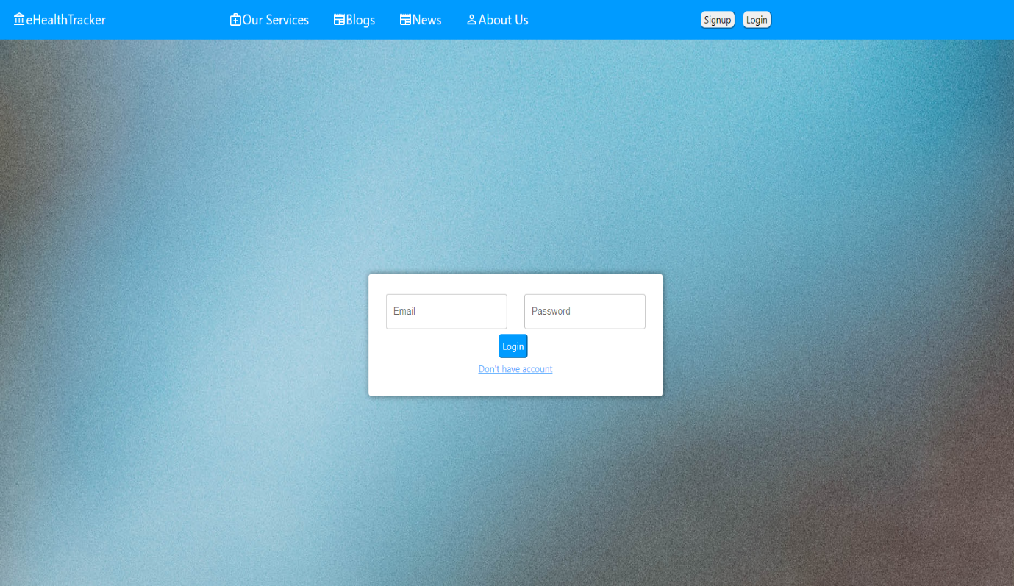

Figure 1.6: Login

*Login page of website where user has to provide credentials.*

### Our Services

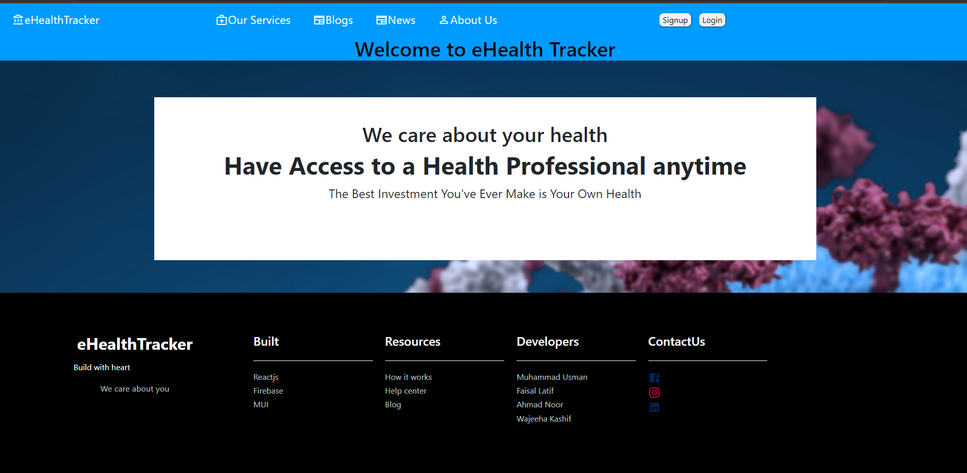

Figure 1.7: Our Services

*Page of our website where all the offered services are shown.*

### Patient’s Profile

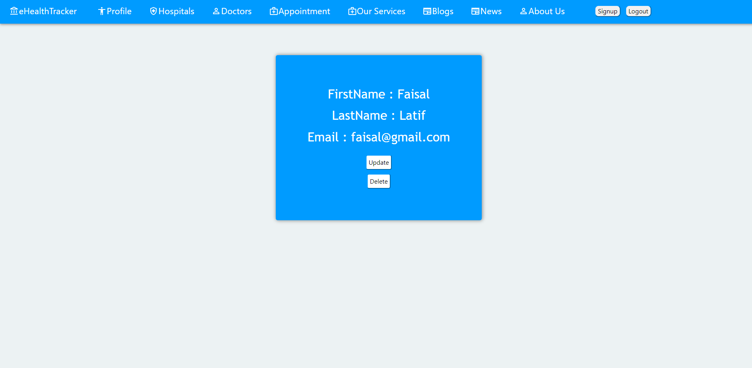

Figure 1.8: Patient’s Profile

*All of relevant data of patient is shown on this page.*

### Book an Appointment



Figure 1.9: Doctor Appointment

*Finding out of relevant doctor can be done on this page.*

### Blogs and News

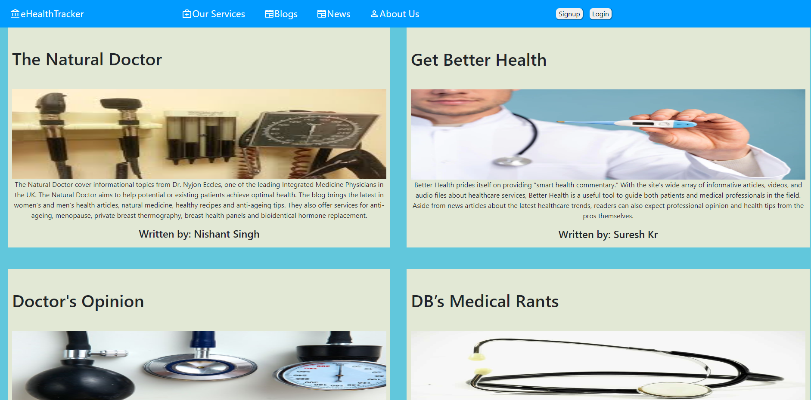

Figure 1.12: Blogs and News

*Interesting blogs and news related to different diseases are shown on this page.*

### About Us

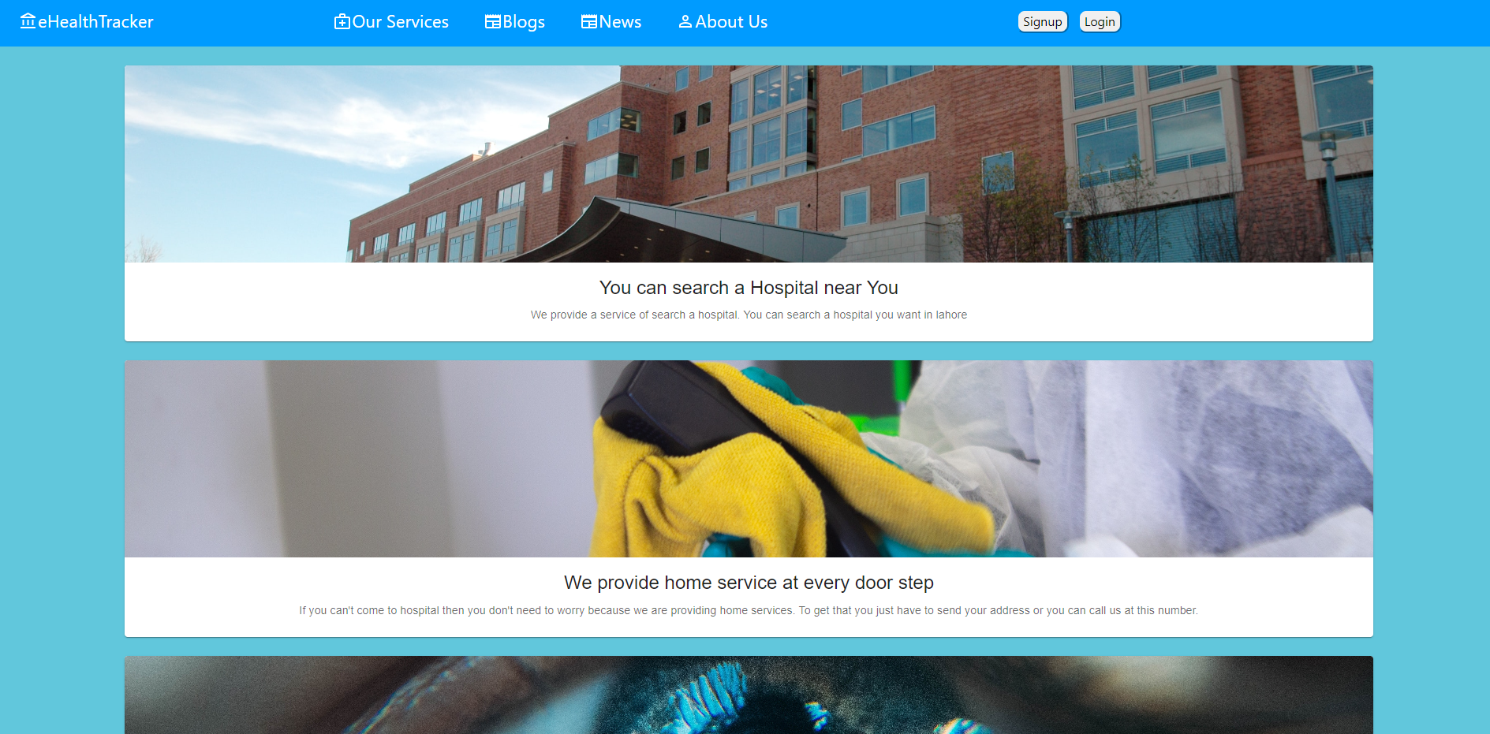

Figure 1.13: About Us

*All Information related to eHealth Tracker will be provided here.*